dentJenkins Setup:

1. Download Jenkins.war file from <http://updates.jenkins-ci.org/download/war/>

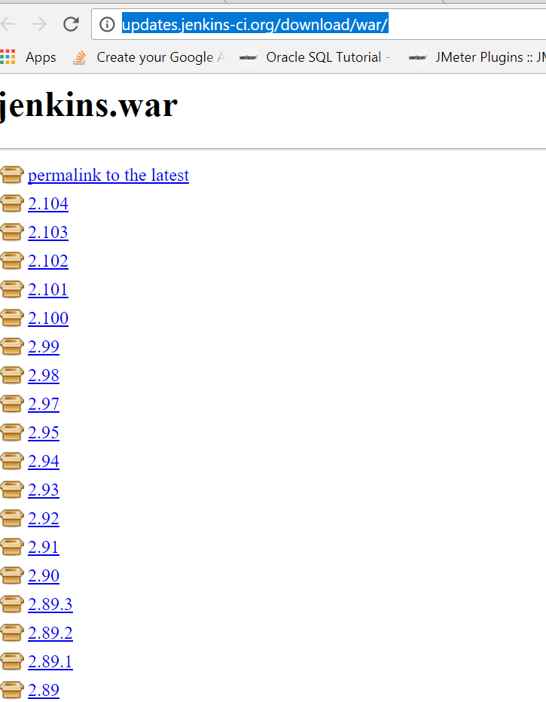

1. Create a folder Name : Jenkins and put your .war file
2. Open CMD and copy jenkins folder path and write cd + folder path :

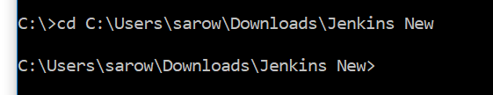

1. Check java : java –version
2. If java installed in your machine than go next or install java
3. Write below code to install Jenkins: java -jar jenkins.war --httpPort=8081
4. Default port is 8080. Try 8080 1st ,if not work than try any other port number like 8081 or 9090
5. 
6. If you don’t write port than it will install default port 8080
7. Press Enter and Jenkins will start
8. Open any browser and write

localhot/9090/manage or <http://localhost:8080/login?from=%2Fmanage>

1. Ist time will see below window
2. 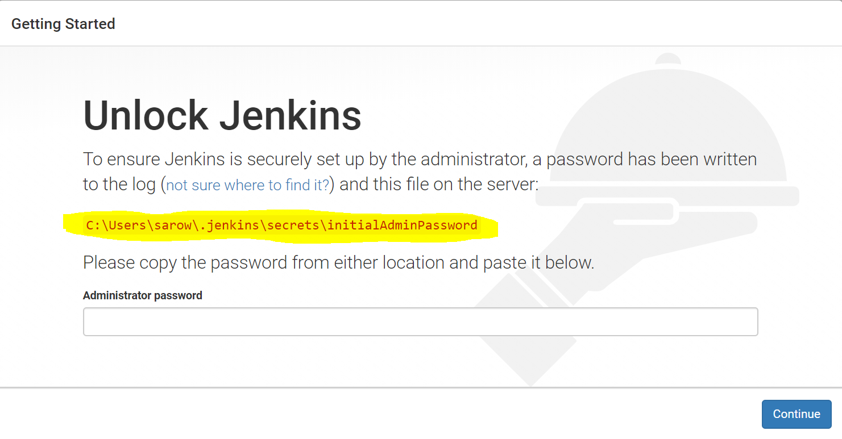
3. Open any folder and copy & paste yellow path
4. 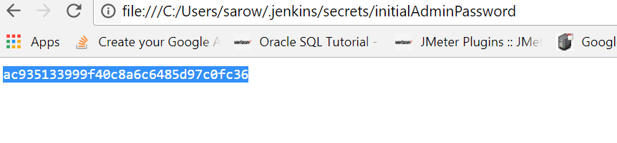
5. You will get admin password of your machine and copy it than paste it in Jenkins
6. 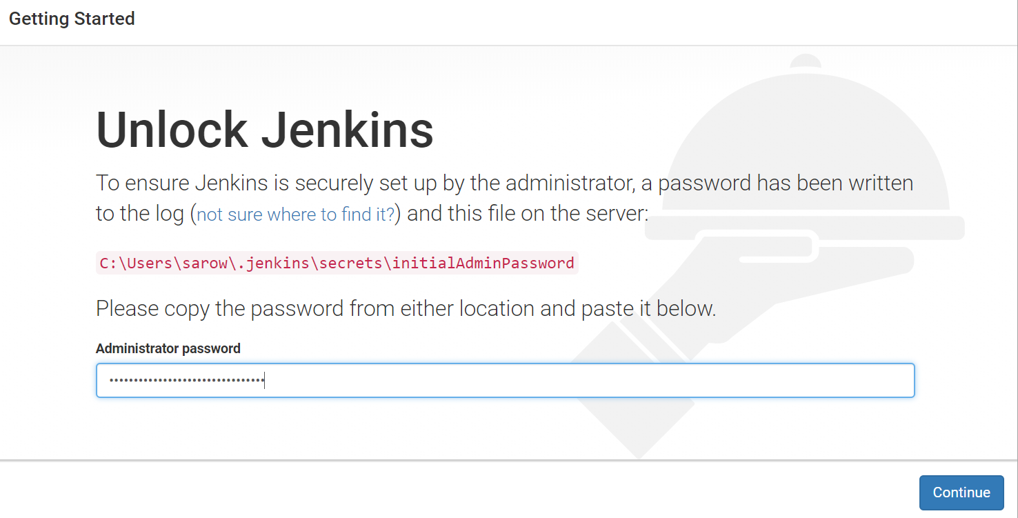
7. Click continue
8. Write <http://localhost:8080> or 9090(which port you mention in CMD)
9. 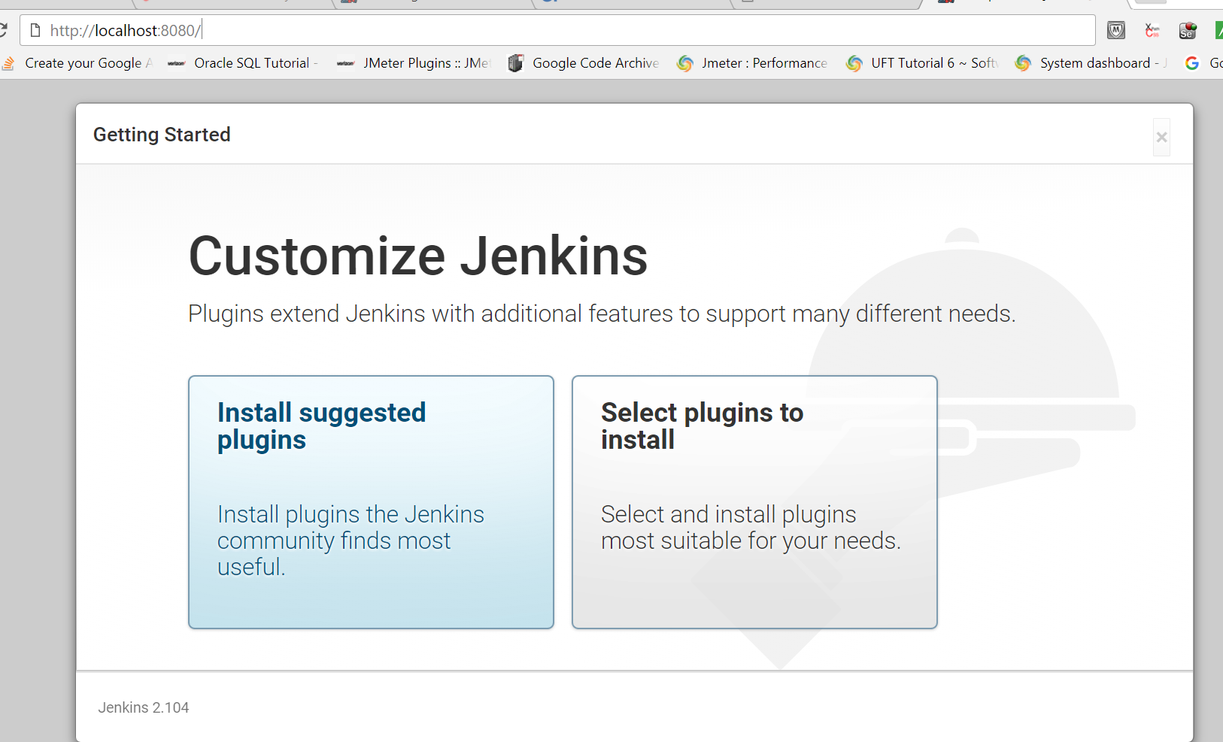
10. Click install suggested plugins
11. All necessary plugin will install It will tell you to create account 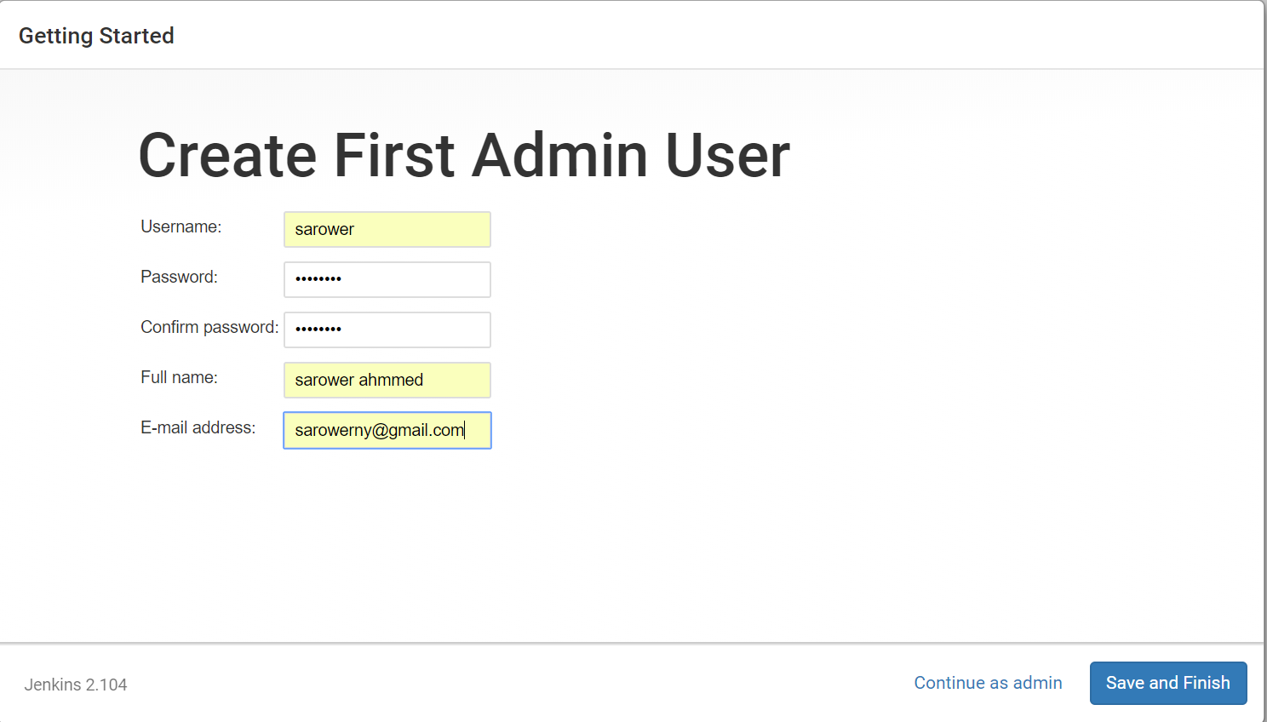
12. Click Save and Finish
13. 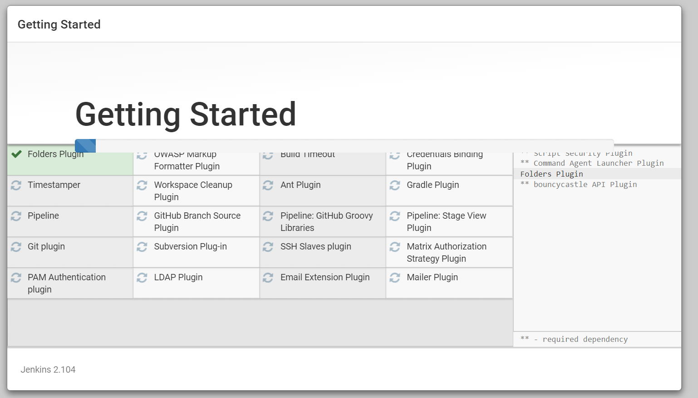
14. You can see Jenkins UI
15. 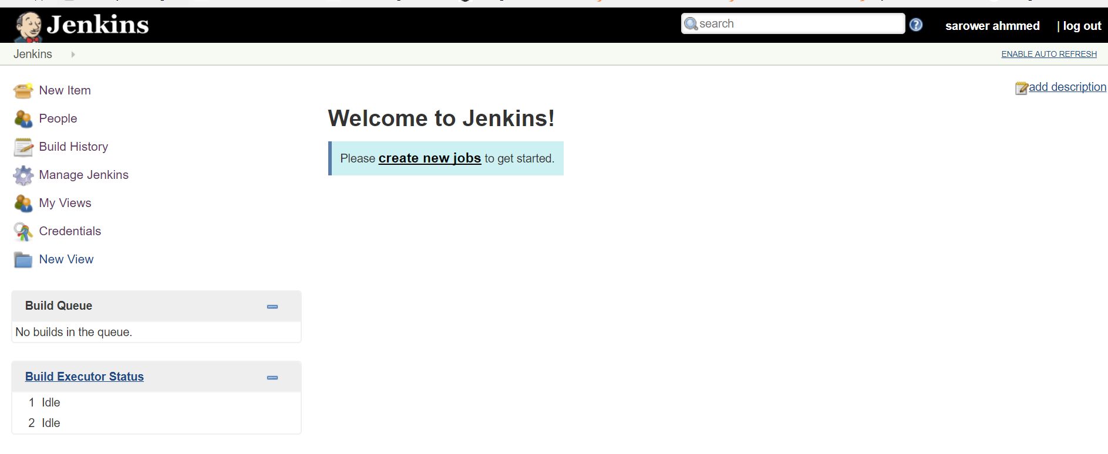

**Cucumber with Jenkins contentious integration (maven & GitHub )**

1. Setup Jenkins as below
2. Download Git and then
3. Go to C:\Program Files\Git

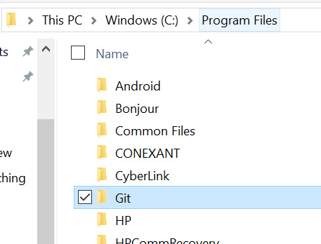

1. Go >>> bin folder inside Git folder::

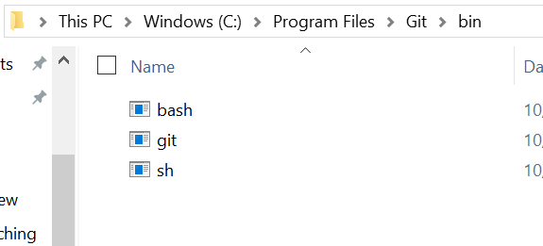

1. Go Jenkins>>> global tool management and
   1. Add Git
   2. Add JDK
   3. Add maven

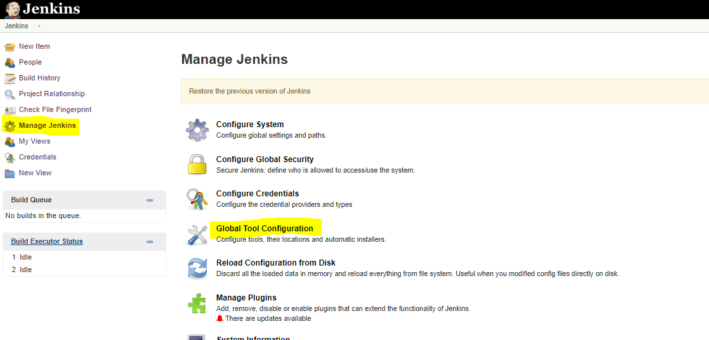

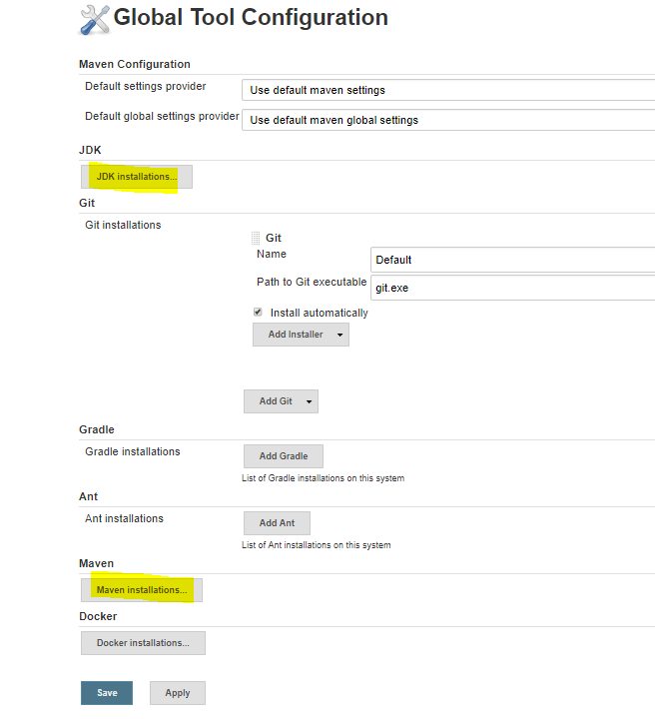

1. JDK setup:

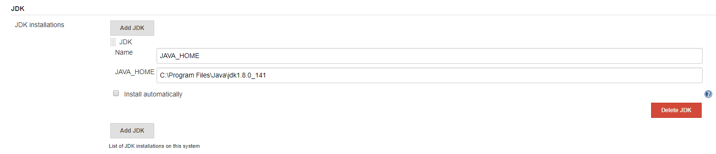

1. Git Setup: with click on install automationcally

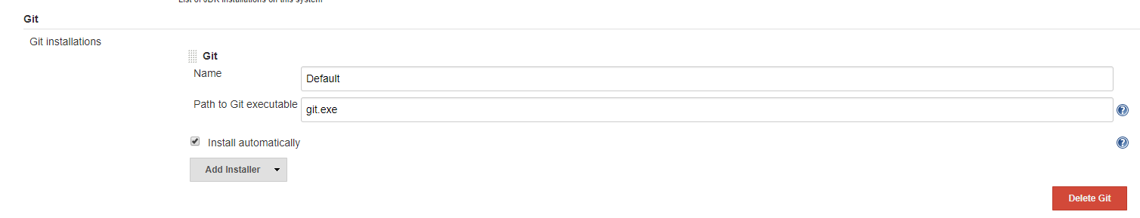

1. If this not work and show red than try to install git from google into your laptop
2. Go >>>> Git >> bin >> git path like below (but remove click automatically)

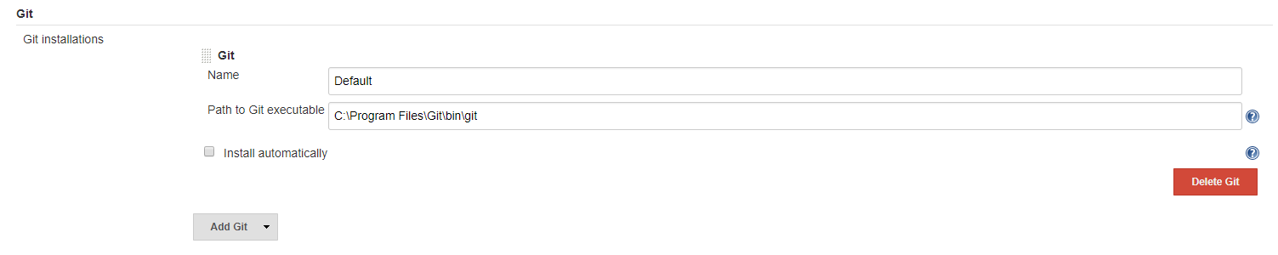

1. Add Maven as below

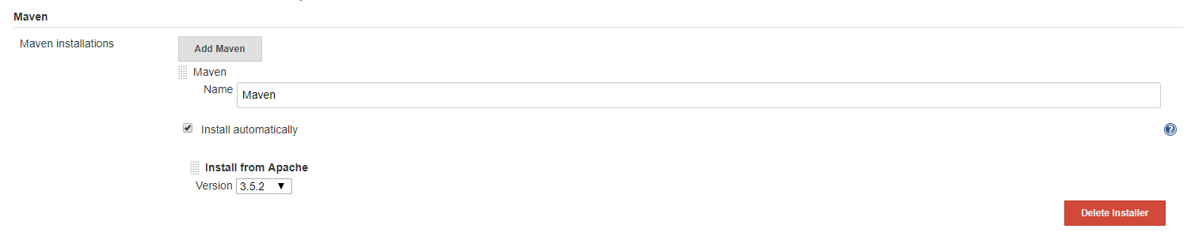

1. Now click save button
2. Go manage Jenkins>> check below plug in install or not
   1. Maven plugin
   2. GitHub integration plugin
   3. Cucumber maven reports

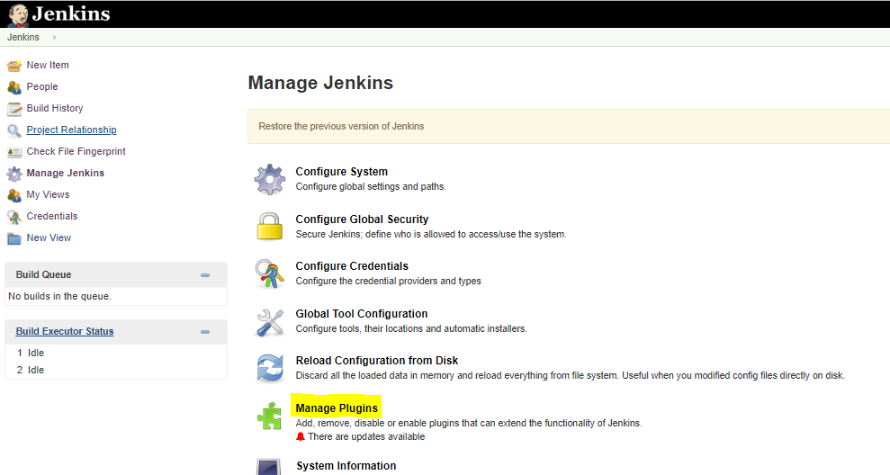

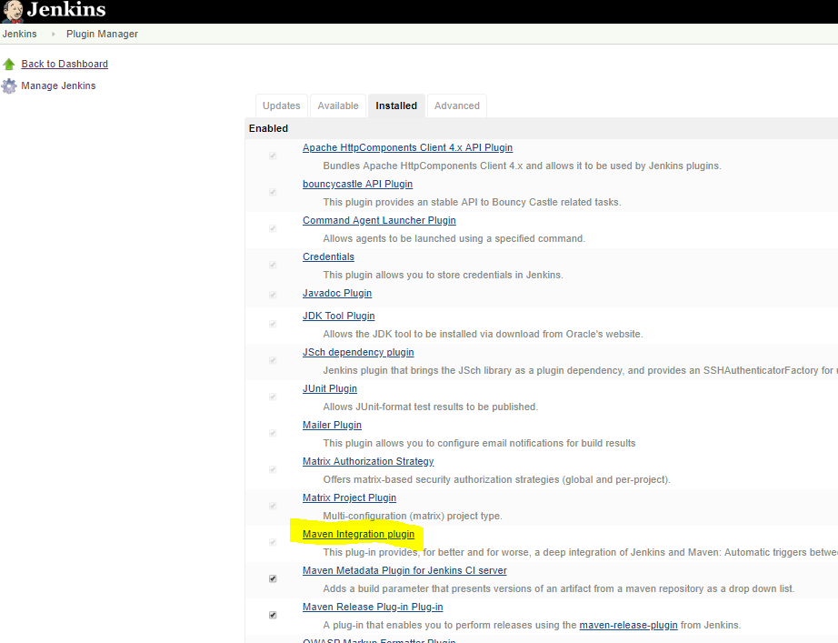

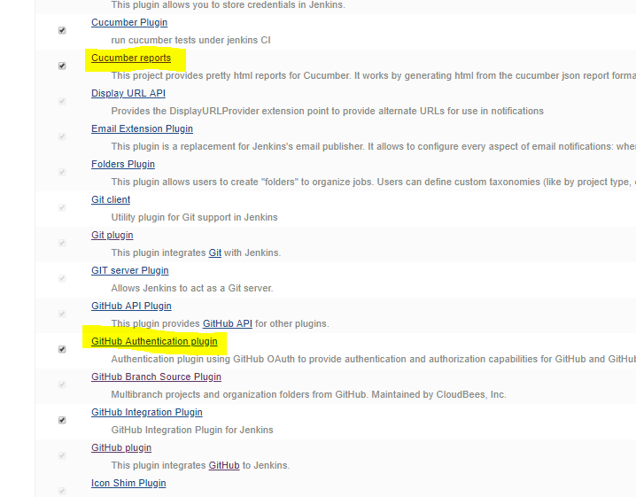

1. Jenkins>>new items>> any name
2. 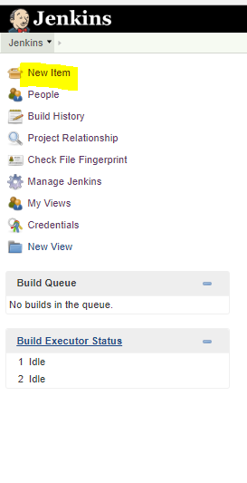

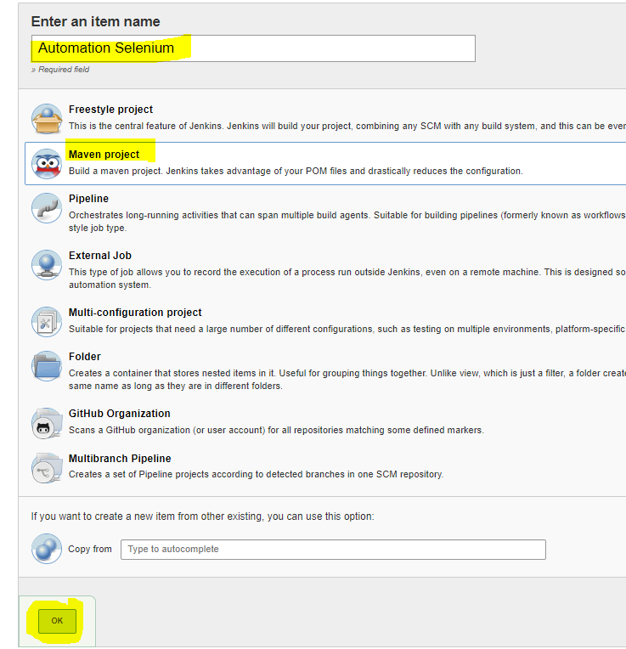

1. Select Maven project>> ok
2. General>>>Select Github project
3. Project URL>>> your Github URL

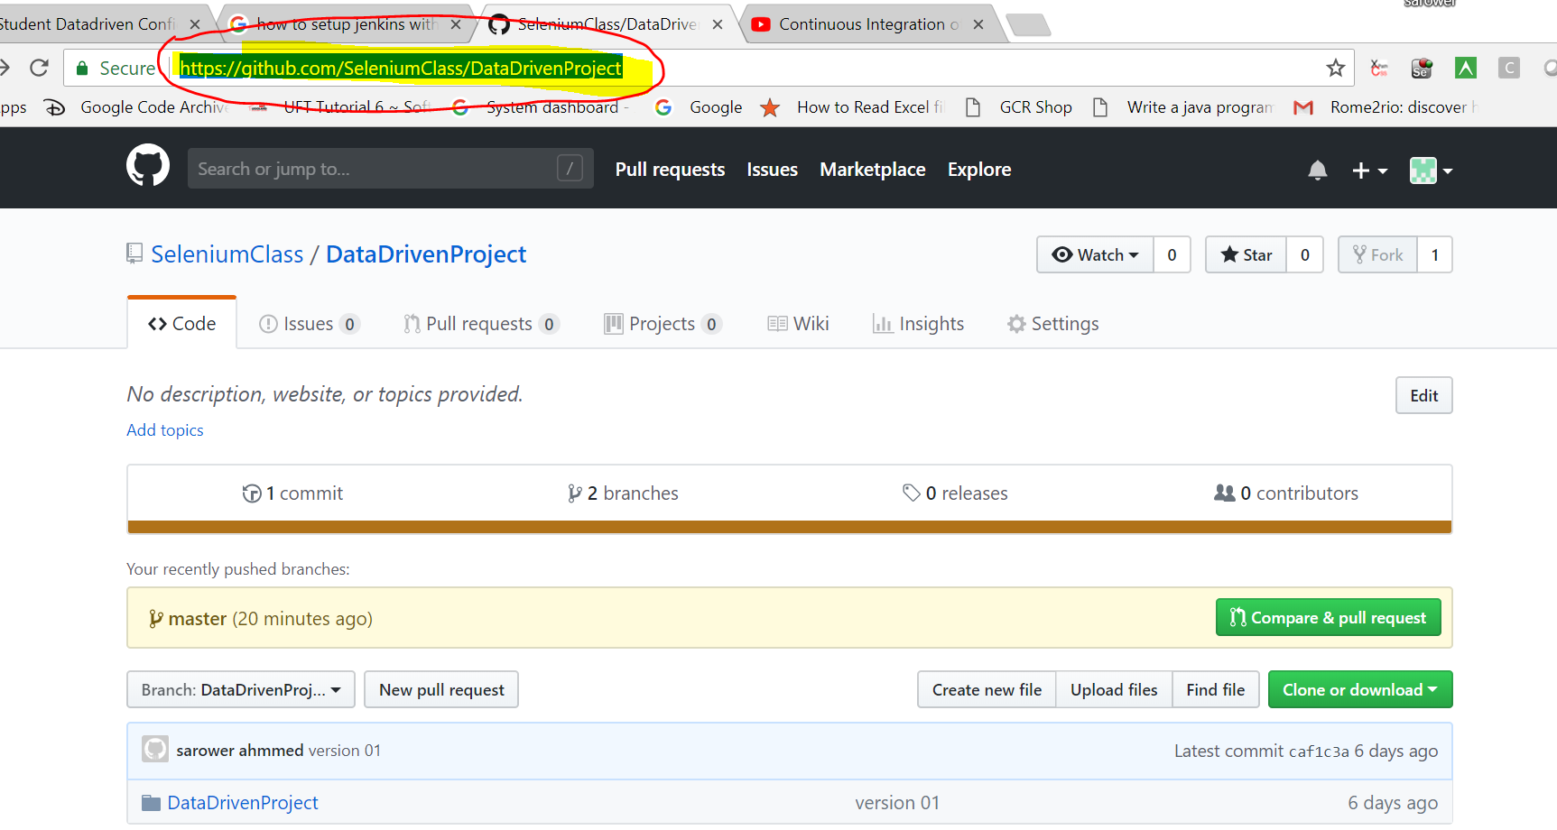

1. Source code management>>>>Select Git

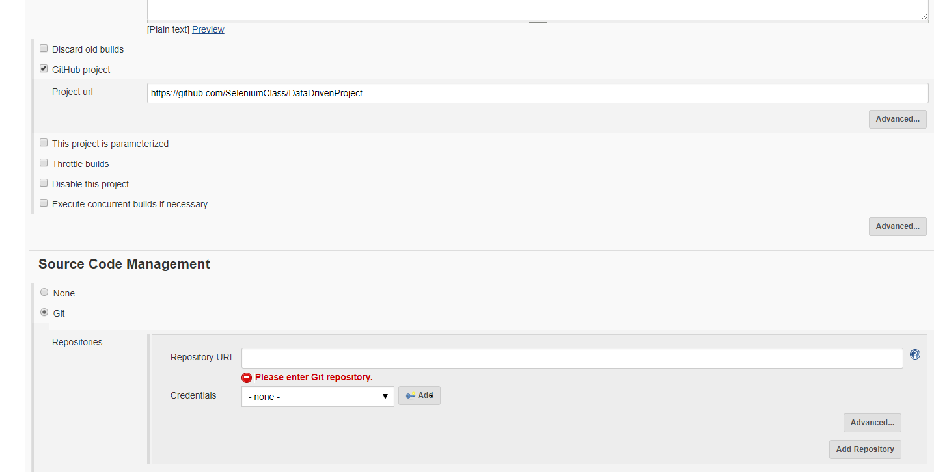

1. Put your repository URL

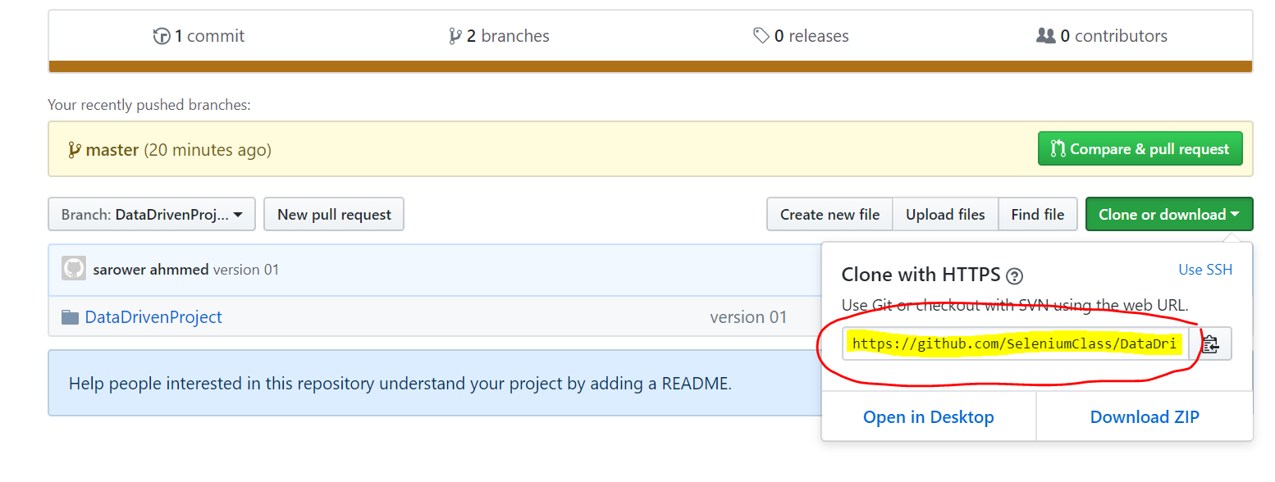

1. Select your github brance or by default master branch

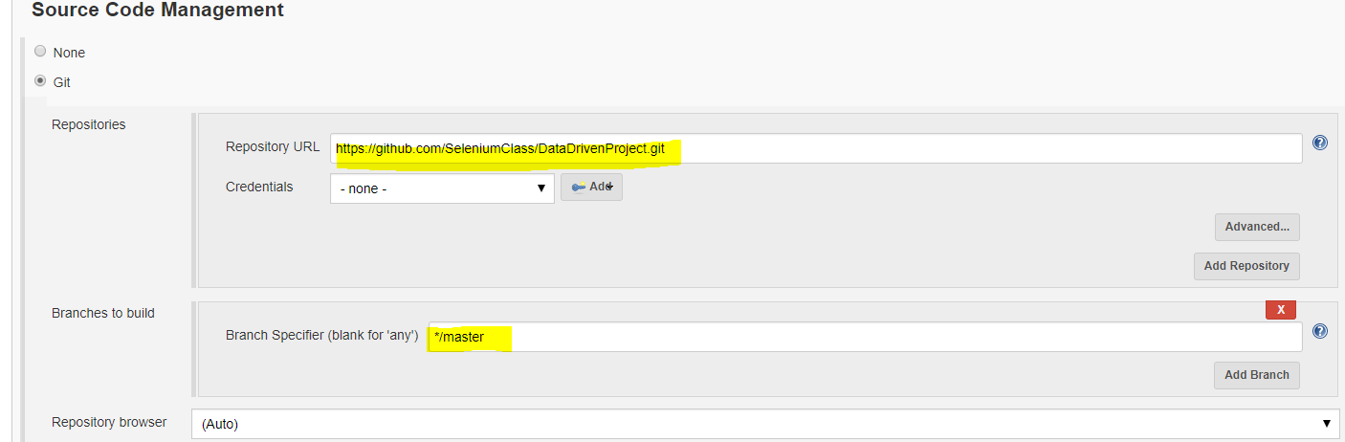

1. Select Build trigger >>

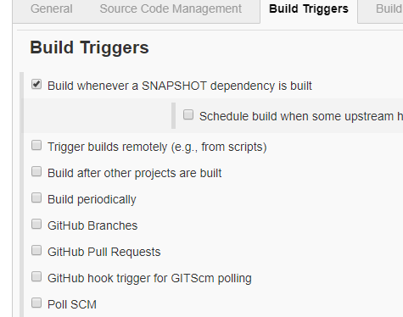

1. Put your project POM.xml path and goal clean instal

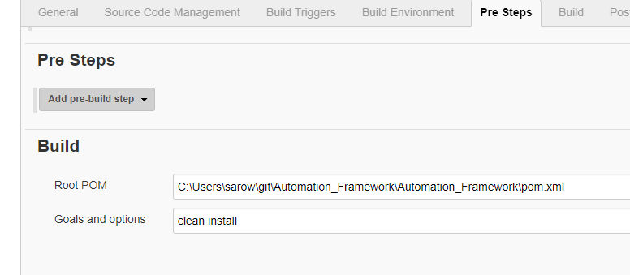

1. How to get POM.xml path

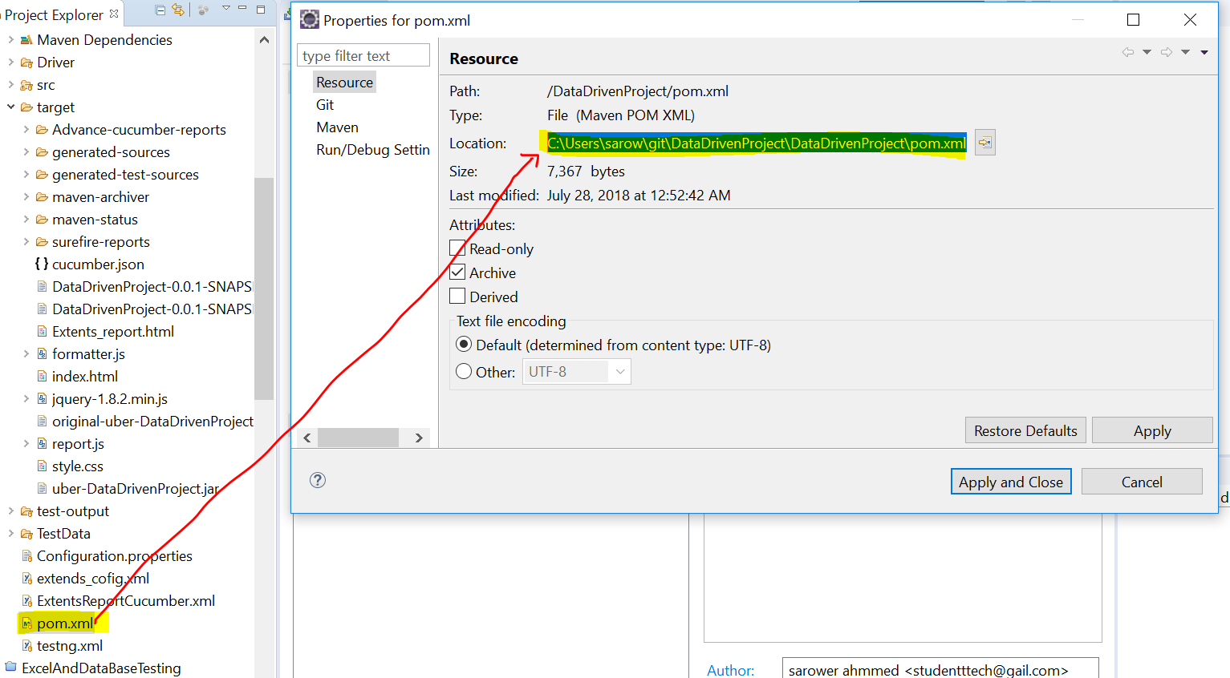

1. Click post build actions

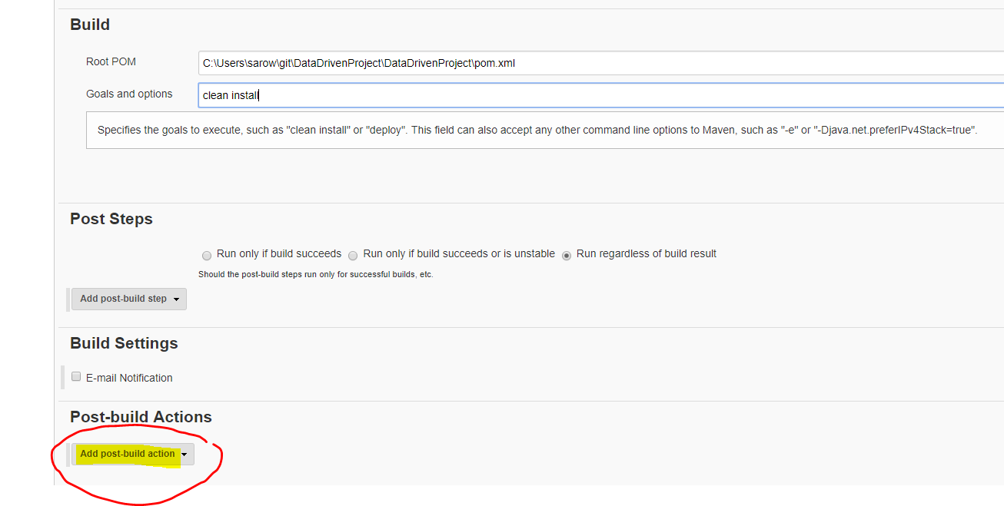

1. Select Cucumber reports

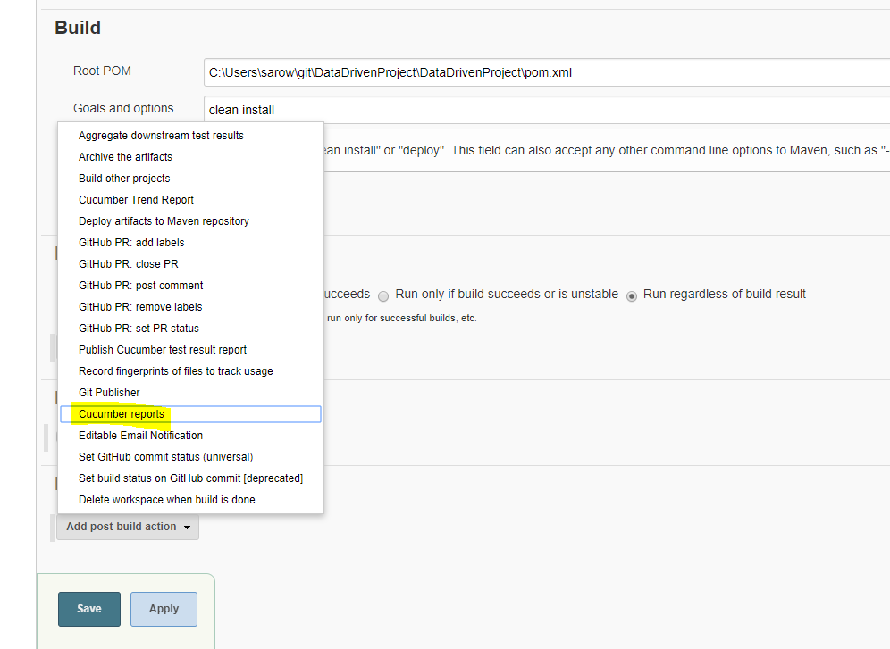

1. Click advanced

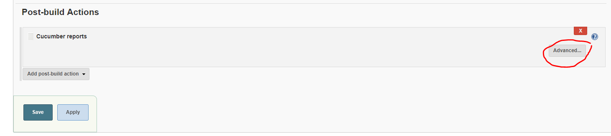

1. Put Jason path

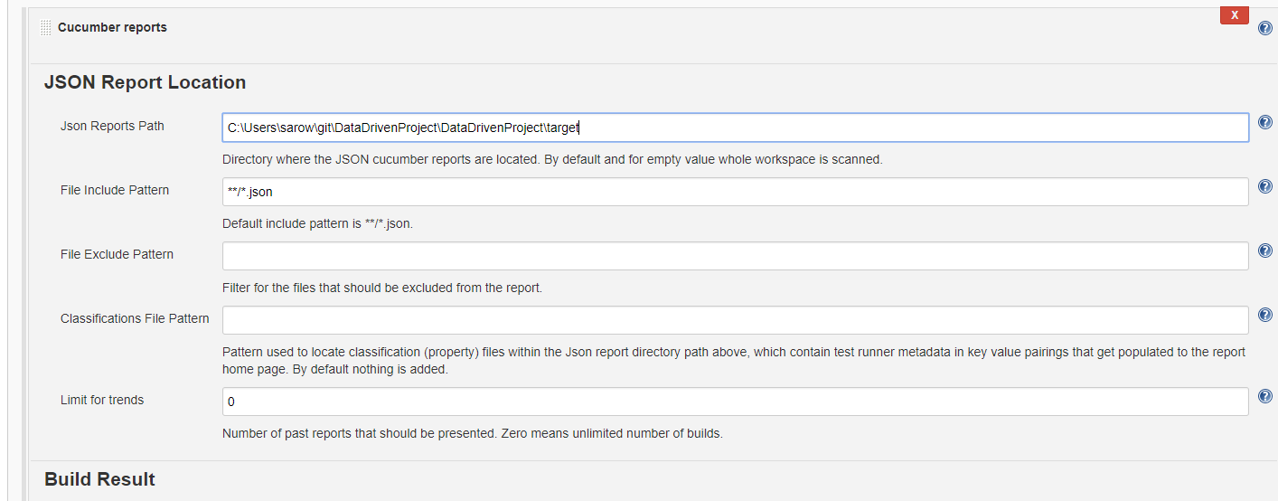

1. How to get json path

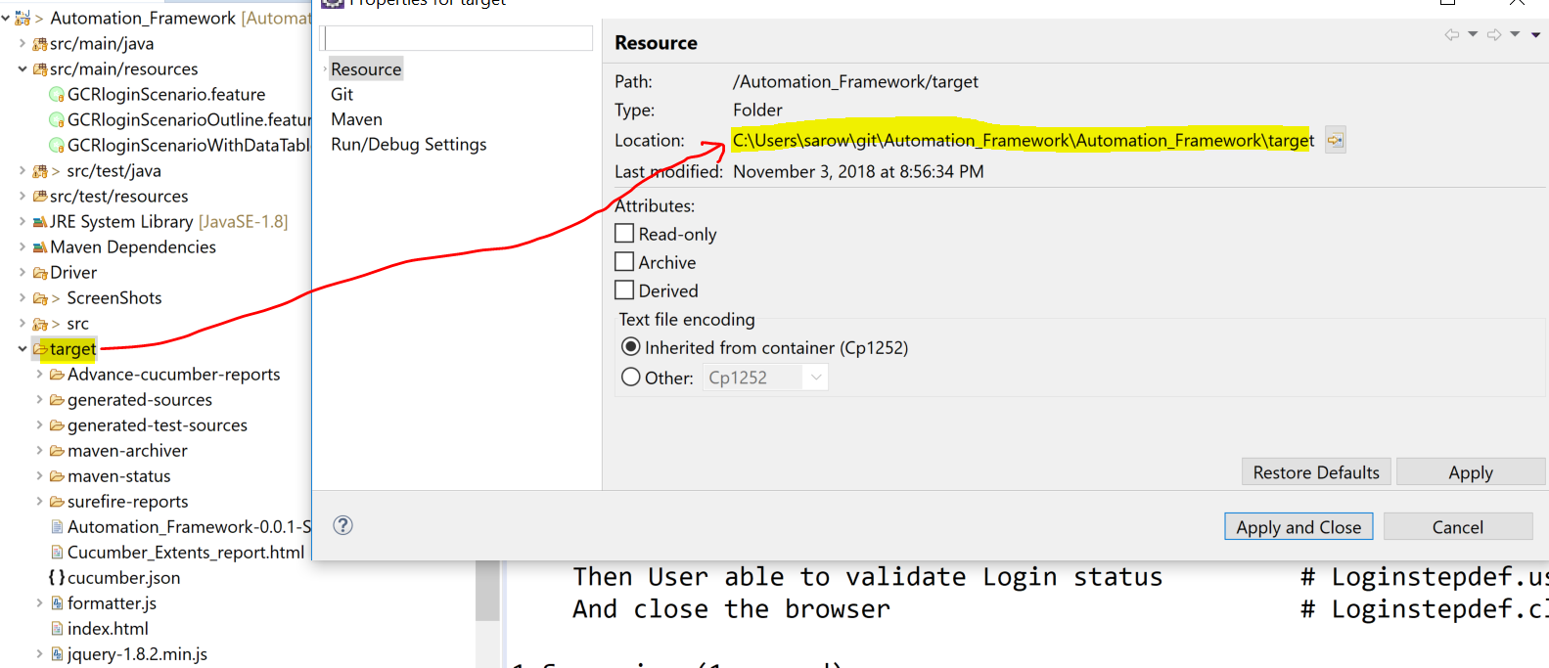

1. Click save button
2. Click Jenkins or back to Dashboard

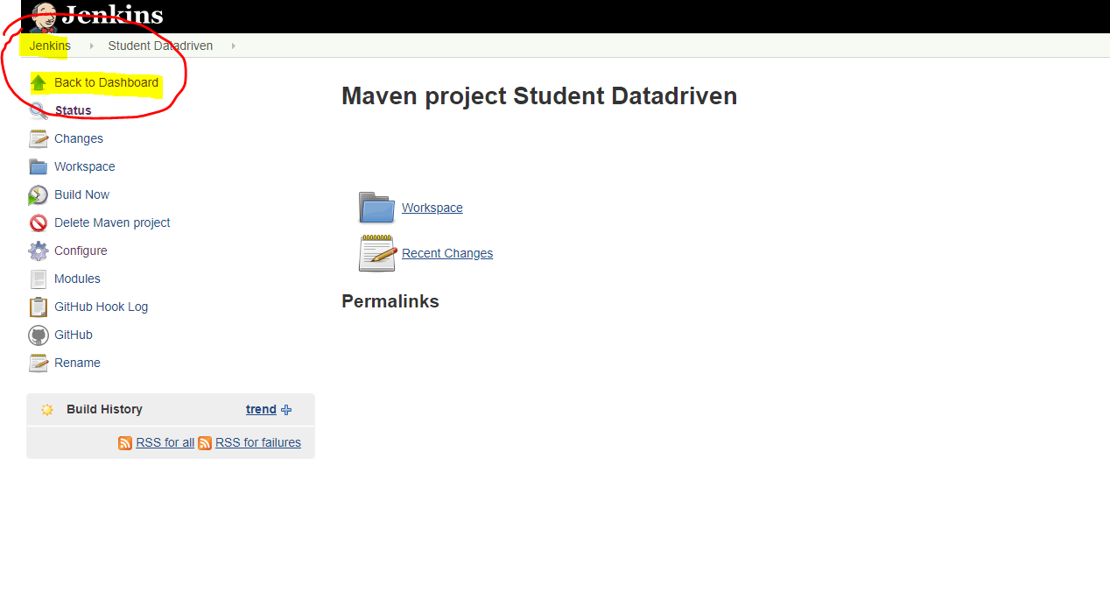

1. You can see your project now

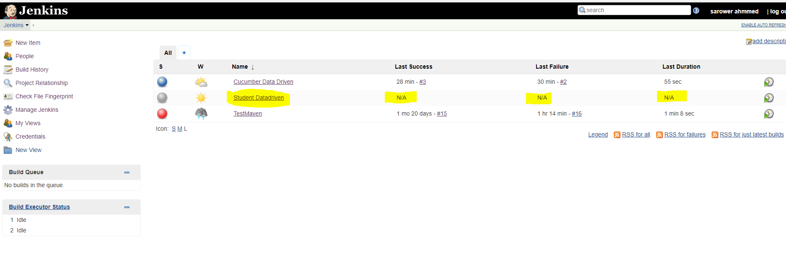

1. Click project name>>drop down >> build now

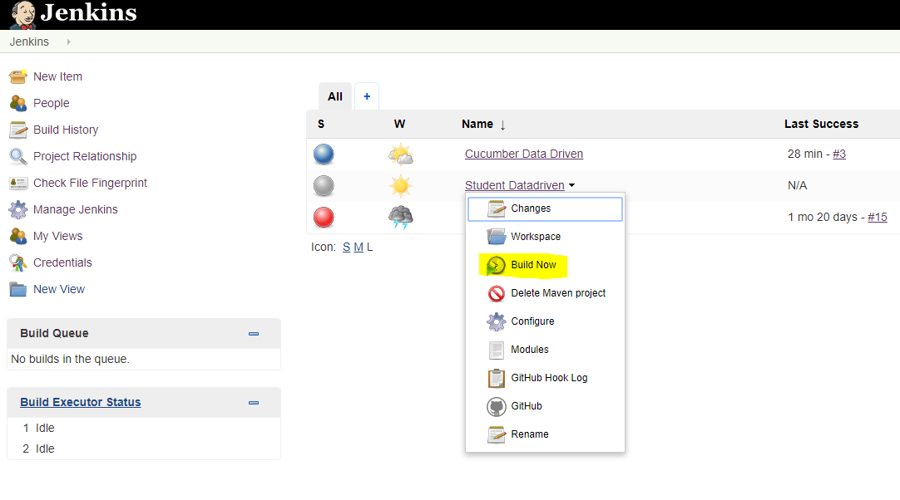

1. Click on # number

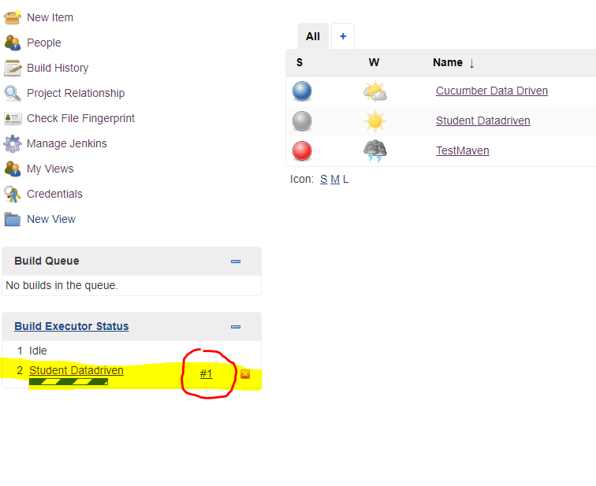

1. Click on console output to see eclipse console , but you cant see browser as its run test case without browser UI🡺 mean you cant see the browser but all test will run in browser=== this process is call headless browser

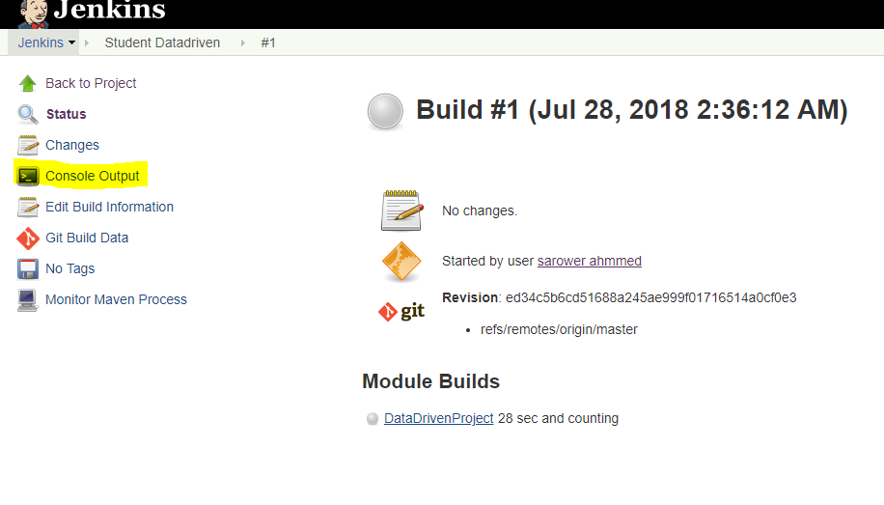

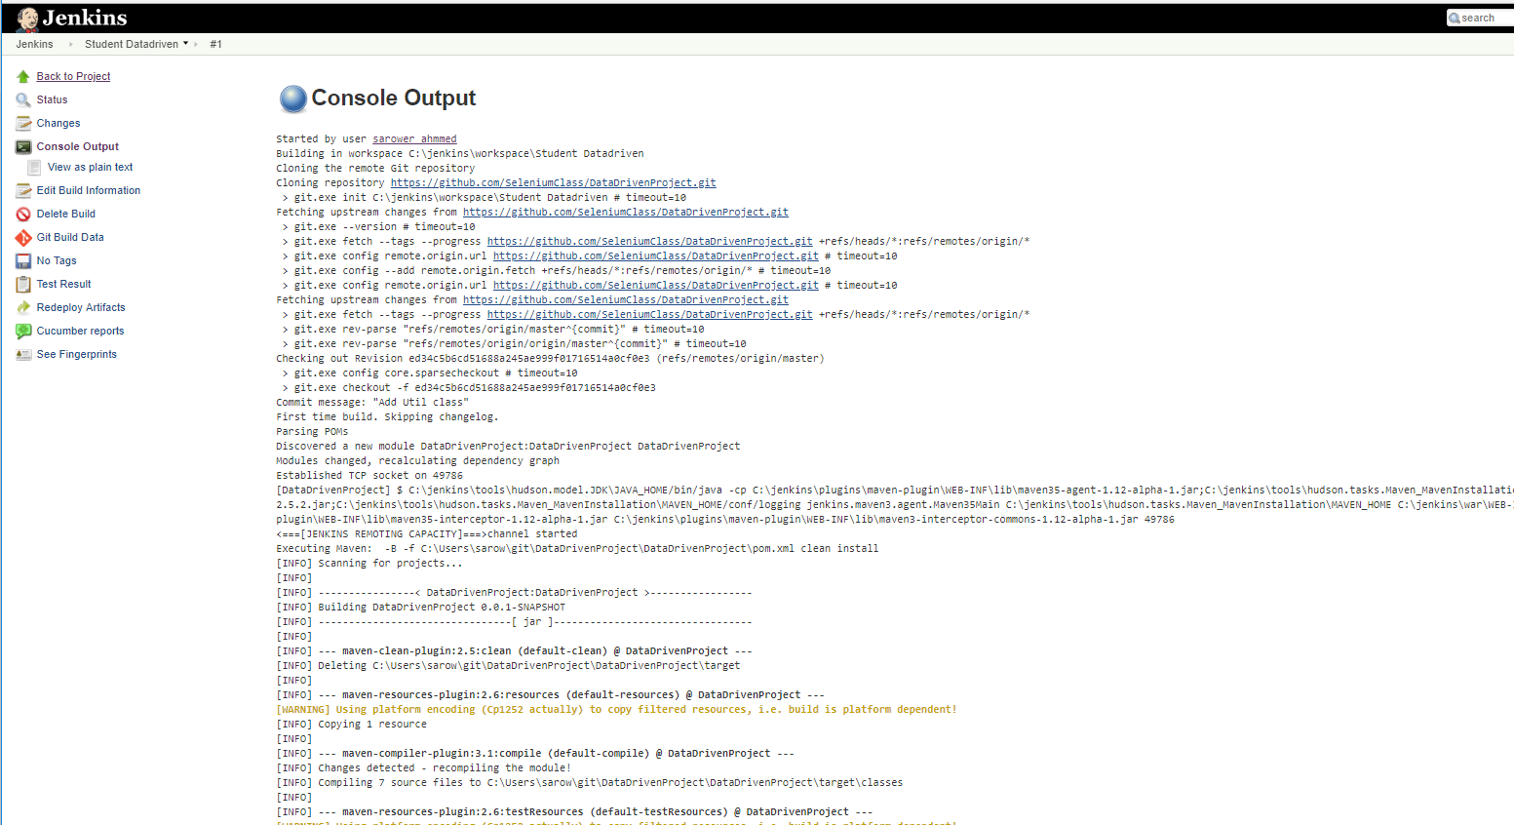

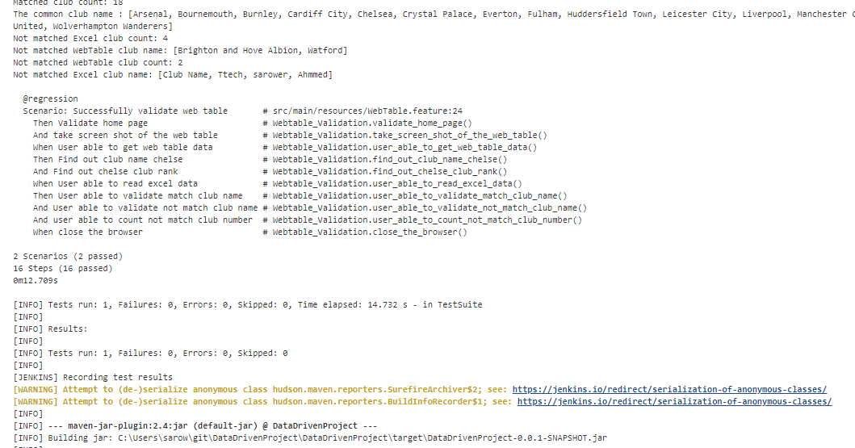

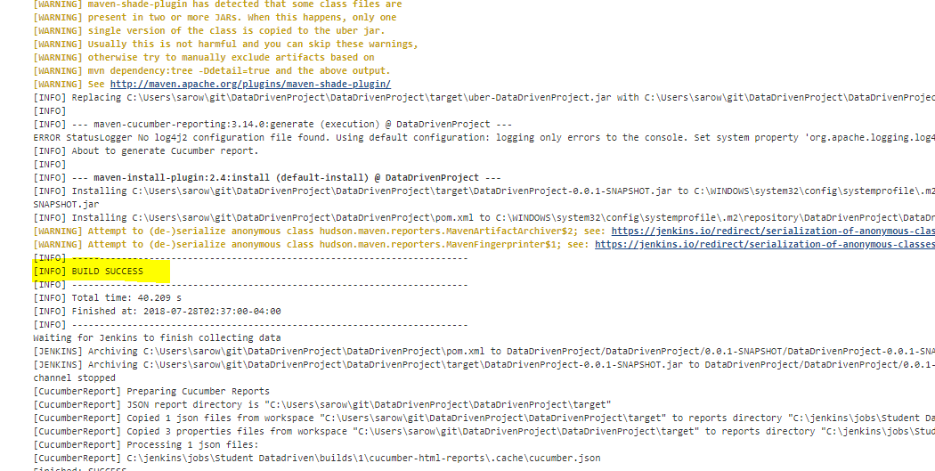

1. Click jenkins>>click your project> you can see the report

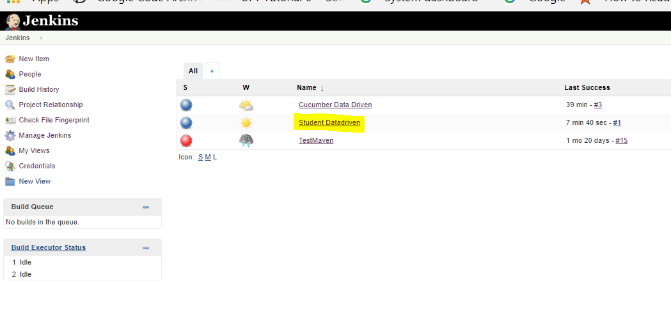

1. Click on cucumber report

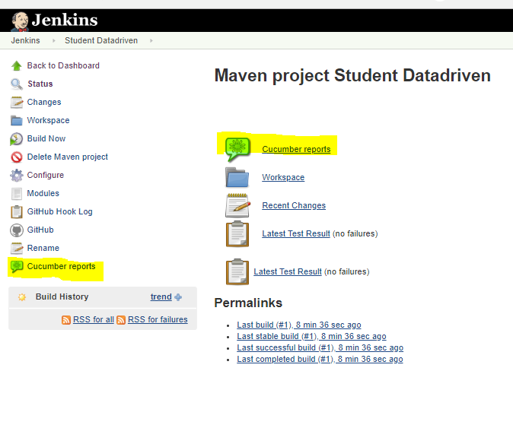

You can see the report:

